**Paradise Lost - fall in lifespan after the Flood**

Here are the recorded lifespans of each generation from Noah until Manasseh – over a period of 38 generations.

|  |  |  |  |  |
| --- | --- | --- | --- | --- |
|  | **A.M.** | **B.C.** | **Generation** | **Lifespan** |
| **Noah** | 1056 | 2847 | 1 | 950 |
| **Shem** | 1558 | 2345 | 2 | 600 |
| **Arphaxad** | 1658 | 2245 | 3 | 438 |
| **Salah** | 1693 | 2210 | 4 | 433 |
| **Eber** | 1723 | 2180 | 5 | 464 |
| **Peleg** | 1757 | 2146 | 6 | 239 |
| **Reu** | 1787 | 2116 | 7 | 239 |
| **Serug** | 1819 | 2084 | 8 | 234 |
| **Nahor** | 1853 | 2050 | 9 | 148 |
| **Terah** | 1882 | 2021 | 10 | 205 |
| **Abraham** | 1952 | 1951 | 11 | 175 |
| **Sarah** | 1962 | 1941 | 11 | 127 |
| **Ishmael** | 2038 | 1865 | 12 | 137 |
| **Isaac** | 2052 | 1851 | 12 | 180 |
| **Jacob** | 2112 | 1791 | 13 | 147 |
| **Joseph** | 2203 | 1700 | 14 | 110 |
| **Levi** | 2200 | 1697 | 14 | 137 |
| **Kohath** | -- | -- | 15 | 133 |
| **Amram** | -- | -- | 16 | 147 |
| **Miriam** | 2371 | 1532 | 17 | 126 |
| **Aaron** | 2374 | 1529 | 17 | 123 |
| **Moses** | 2377 | 1526 | 17 | 120 |
| **Joshua** | -- | -- | 25 | 110 |
| **David** | 2931 | 972 | 24 | 70 |
| **Rehoboam** | 2988 | 915 | 26 | 58 |
| **Jehoshaphat** | 3054 | 849 | 29 | 60 |
| **Jehoram** | 3061 | 842 | 30 | 40 |
| **Jotham** | 3171 | 732 | 35 | 41 |
| **Ahaz** | 3187 | 716 | 36 | 36 |
| **Hezekiah** | 3216 | 687 | 37 | 54 |
| **Manasseh** | 3260 | 643 | 38 | 67 |

**A continuous decline with each generation**

When plotted on a graph of lifespan against generation, a continuous decline in lifespan over 38 generations is discernable.

Excel automatically generates the best fit trendline. The equation is displayed on the graph below.

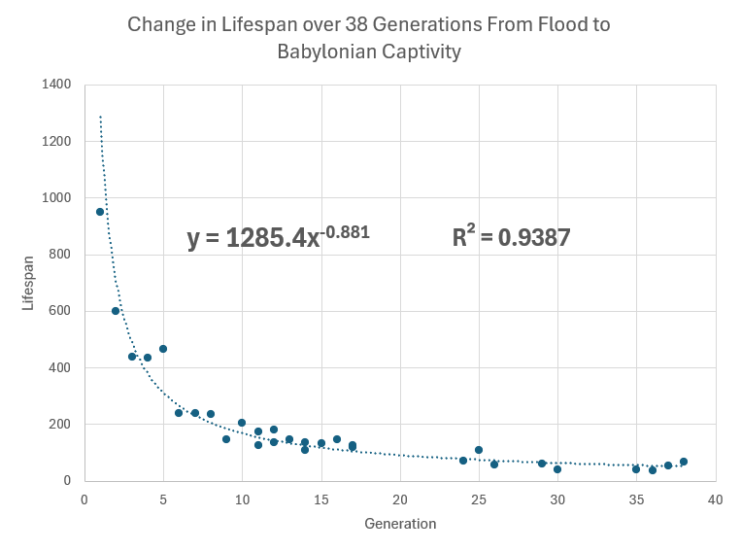

**Were these numbers invented ?**

*“One important point, often overlooked, is that the data are not just found in Genesis 5 and 11. Instead, when you examine the rest of the Bible, we see that the declining trend spans the entire biblical period. Initially, the post-Flood people were living for several centuries. Ten or more generations later, Abraham, Isaac, and Jacob also lived for very long times, but not nearly as long as their ancestors. A few generations after this, the siblings Moses, Aaron, and Miriam died right at the upper edge of the modern human lifespan. By the time we get to king David, we are essentially in the ‘normal’ range of human lifespan. Yet, when combined, the ages fall into a beautiful mathematical continuum. Had someone invented those numbers, perhaps in a scenario where Genesis was written much later than conservative scholars assert, would they have thought to go through the rest of Scripture, teasing out the minutiae that are often buried in inconsequential locations and making sure they also fit the pattern? Consider that ancient people did not have the mathematical tools we have today. Nobody had ever made a graph, and they had only a vague sense of a timeline. They did not have the tools required to fit exponential decay curves to consecutive data points and, since their contemporaries would not have rejected the thought of long lifespans, little reason even to try… Fitting a power function to the biblical data (figure 1), we can see that each generation lives, on average, about 88% as long as the generation prior. Amazingly, the data are very consistent, with an “R-squared” value of 0.94. In other words, the line encompasses about 94% of the variation in the data set. A perfect fit would equal 1.0.”*

The decline in lifespan took place over a long period of time – 38 generations – a period of 2200 years.

**Masoretic vs Septuagint**

Here I have listed the lifespans of the patriarchs from Noah to Abraham as found in the genealogies of the Masoretic text and the Septuagint.

1. Excel was used to determine the best fit decay curve in each case.
2. The degree of variance from this curve was calculated to see which genealogy best fitted a natural decay pattern.

It was found that the Masoretic genealogy has a better fit to a decay curve compared to the Septuagint genealogy. R2 was 0.9426 for Masoretic compared to 0.8103 for Septuagint; the difference is therefore 13%.

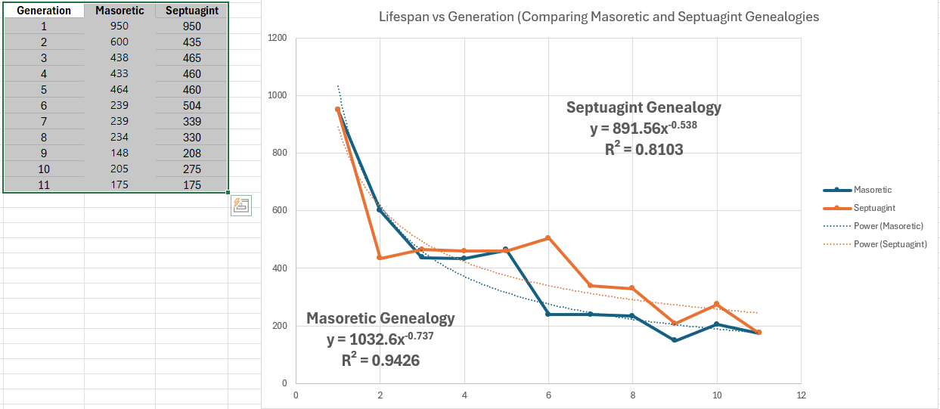

Both the Septuagint and the Masoretic text show a constant decline in lifespan, though the Masoretic genealogy shows a smoother exponential decline.

**A continuous decline with each year**

So far we have plotted lifespan against generation. Will the same pattern hold up when lifespan is plotted against year of birth?

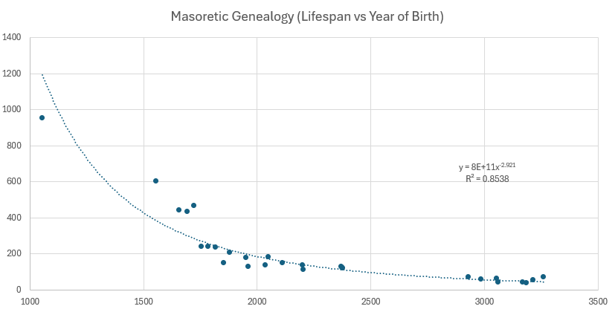

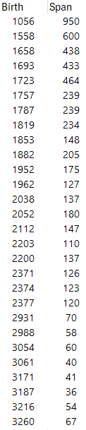**A Cause**

As you can see, an exponential decrease is still observed, persisting over a period of 2200 years - though its correlation with year of birth is not as strong as the correlation with generation. The reduction in lifespan therefore seems determined by the number of reproductive cycles rather than by the number of years between them.

In other words, whatever is producing the decline in lifespan is having an effect at the time of conception rather than at any time between. The decrease in lifespan must be due to a process affecting division of sex cells during meiosis rather than division of non-sex cells during mitosis. It is possible that copying errors are being introduced with each division of the germ cells resulting in a decline in fitness.

This damage seems to accumulate with each generation.

**Restoration**

The DNA of early humans as determined from skeletal or frozen remains, may tell us what genetic information has been lost, and this may be useful for increasing health-span and lifespan.

**What are the Implications of Paradise Lost**

1. Life is devolving rather than evolving. With each generation there is a gradual accumulation of damage that is passed on to the next generation.

2. In the beginning there was greater health and longer lifespan, suggesting an initial paradise, and representing the intention of the Creator.

3. The idea of eternal life and of a new heavens and new earth follows naturally in the context of something we once had. It will be restored at the end.

Exponential Decay by Date of Birth

[Exponential Decay Old Testament Genealogies | Answers Research Journal](https://answersresearchjournal.org/decay-curve-old-testament-genealogies/)

Exponential Decay by Generation

[The rapid decline in biblical lifespans (creation.com)](https://creation.com/rapid-decline-biblical-lifespans)

Degree of Variation from a Best Fit Decay Curve (Comparison of Masoretic and Septuagint Genealogies)

[The Septuagint vs. The Masoretic Text … A Statistical Perspective (cedarville.edu)](https://digitalcommons.cedarville.edu/cgi/viewcontent.cgi?article=1555&context=icc_proceedings)

Genealogy Septuagint vs Masoretic

<https://digitalcommons.cedarville.edu/cgi/viewcontent.cgi?article=1192&context=icc_proceedings>

[Septuagintal Versus Masoretic Chronology in Genesis 5 and 11 (cedarville.edu)](https://digitalcommons.cedarville.edu/cgi/viewcontent.cgi?article=1192&context=icc_proceedings)

[Microsoft Word - jets64a.doc (etsjets.org)](https://www.etsjets.org/files/JETS-PDFs/64/64-1/JETS_64.1_25-43_Steinmann.pdf)